# Question 2A

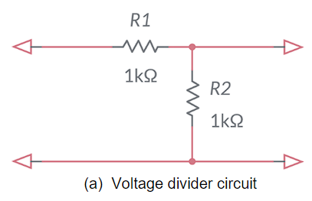

$$\begin{matrix}V_{out}=\frac{R_{2}}{R_{1}+R_{2}}V_{in}\end{matrix}$$

$$\begin{matrix}\frac{V_{out}}{V_{in}}=0.5\end{matrix}$$

$$\begin{matrix}H\left(s\right)=0.5\end{matrix}$$

This is a zero order and static system

# Question 2B

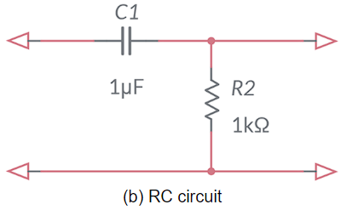

Converting to laplase domain $C_{1}=\frac{1}{sC}$

$$\begin{matrix}\frac{V_{out}}{V_{in}}=\frac{R_{2}}{\frac{1}{sC}+R_{2}}\end{matrix}$$

$$\begin{matrix}\frac{V_{out}}{V_{in}}=\frac{R_{2}sC}{1+R_{2}sC}\end{matrix}$$

$$\begin{matrix}H\left(S\right)=\frac{s}{s+{10}^{3}}\end{matrix}$$

This is a first order and dynamic system

# Question 2C

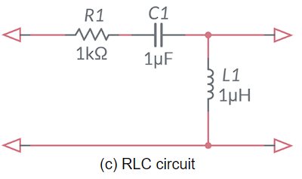

converting to laplase domain $C_{1}=\frac{1}{sC},L_{1}=sL$.

$$\begin{matrix}\frac{V_{out}}{V_{in}}=\frac{sL}{R_{1}+\frac{1}{sC}+sL}\end{matrix}$$

$$\begin{matrix}\frac{V_{out}}{V_{in}}=\frac{s^{2}LC}{s^{2}LC+sR_{1}C+1}\end{matrix}$$

$$\begin{matrix}H\left(S\right)=\frac{s^{2}LC}{s^{2}LC+sR_{1}C+1}\end{matrix}$$

$$\begin{matrix}H\left(S\right)=\frac{s^{2}{10}^{−12}}{s^{2}{10}^{−12}+s{10}^{−3}+1}\end{matrix}$$

$$\begin{matrix}H\left(S\right)=\frac{s^{2}}{s^{2}+s{10}^{9}+{10}^{12}}\end{matrix}$$

This is a second order and dynamic system

# Question 2D

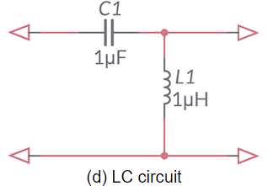

converting to laplase domain $C_{1}=\frac{1}{sC},L_{1}=sL$.

$$\begin{matrix}\frac{V_{out}}{V_{in}}=\frac{sL}{\frac{1}{sC}+sL}\end{matrix}$$

$$\begin{matrix}\frac{V_{out}}{V_{in}}=\frac{s^{2}LC}{s^{2}LC+1}\end{matrix}$$

$$\begin{matrix}H\left(S\right)=\frac{s^{2}LC}{s^{2}LC+1}\end{matrix}$$

$$\begin{matrix}H\left(S\right)=\frac{s^{2}{10}^{−12}}{s^{2}{10}^{−12}+1}\end{matrix}$$

$$\begin{matrix}H\left(S\right)=\frac{s^{2}}{s^{2}+{10}^{12}}\end{matrix}$$

This is a second order and dynamic system